Dr. Laurie Bernstein, Associate Professor of History
Email: laurie.bernstein@rutgers.edu
Voicemail: 856-225-2716
Class meetings in Fine Arts 227, Tuesday/Thursday 9:35-10:55am
Office hours Tuesday 8:30-9:30am, Thursday 11am-12noon in 429 Cooper St., #202

Fall 2018 course syllabus for History 50:510:380
From Peter the Great to Putin: Empire in Russia

This course explores the expansion and contraction of the Russian and Soviet empires through a close look at the foreign policies and reigns of the most influential figures at the helm of the state from the late seventeenth through the early twenty-first centuries. In addition to reading our text, secondary sources, and primary sources, we will consider 19th-century fictional and 20th-century cinematic representations of the peoples within and without the empires.

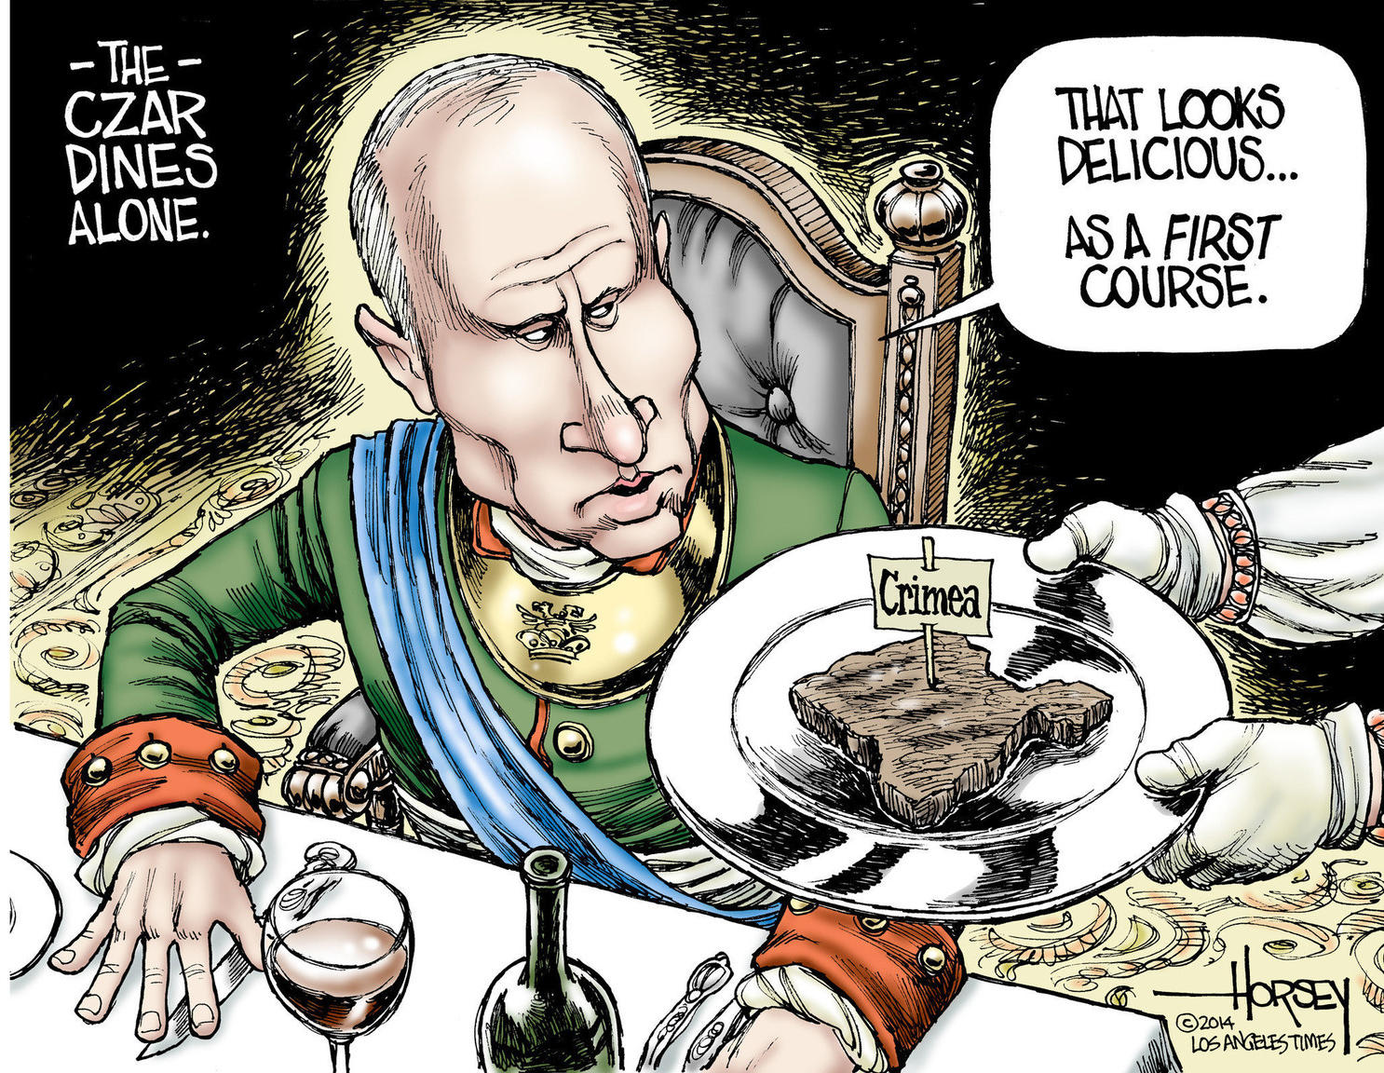
Required reading
Valerie A. Kivelson and Ronald Grigor Suny, Russia’s Empires (New York: Oxford University Press, 2017) ISBN 978-0-19-992439-4
Primary and secondary sources available on Sakai Resources will be assigned for each unit

Requirements
Conduct, attendance, and participation (10 points)
You are expected to attend every class, to arrive on time, to come prepared in terms of the reading and writing assignments, and to participate civilly in class discussions. You are also expected to remain in the classroom during our sessions – exceptions will be made for emergencies so long as I am notified in advance. Electronic and mobile devices are to be turned off and to be kept out of reach during class time – exceptions will be made if you are in the midst of a family emergency so long as I am notified in advance. Please be courteous and inform me by email or voicemail prior to class if you will not be able to attend. NB: Please keep in mind that communications between us should not be treated as texts among friends, but as formal and professional correspondence. In other words, written communications should begin with a polite address, they should be written carefully and grammatically, and they should be signed with your full name.
Comments on Kivelson & Suny (30 points)
Before the start of each class that has a reading assignment from Kivelson & Suny, you are to submit via Sakai Assignments carefully written comments that (1) put something particularly striking from the reading in your own words (with page references inside parentheses; (2) articulate why you find this fact or idea so interesting in terms of historical questions about the Russian or Soviet empire; and (3) raise a relevant question for our class discussion. Each set of comments is worth up to 3 points. See Sakai Assignments for the precise guidelines on expectations and grading.
Short papers on our secondary sources (35 points)
Before the start of each class with an assignment from our secondary sources, you are to turn in a carefully written short paper on Sakai Assignments that summarizes and explains the author’s overall argument in the article in your own words, and then and comments on how the author’s main idea (his or her argument) agrees with and/or disagrees with what you have read in Kivelson & Suny. You may revise and resubmit your first three papers within one week of receiving my suggestions for consideration of a higher grade. Each paper is worth up to 5 points. See Sakai Assignments for the precise guidelines on expectations and grading.
Short quizzes on the three short stories (9 points)
Before the start of each class with a reading assignment by the authors Pushkin, Tolstoy, and Turgenev, there will be a short quiz to make sure you have come prepared for our class discussion of these sources.
Oral presentation on a contemporary source (15 points)
On November 29 and December 4, students will be responsible for guiding the class through a reliable contemporary article on Putin’s policy toward non-Russian nationalities who were once or who still remain part of the Russian/Soviet empire. See Sakai Assignments for the precise guidelines on expectations and grading.
Final exam (10) points)
On RUC’s scheduled time and date, there will be a final exam on the course as a whole.

NB: Students with documented disabilities should contact our Office of Disability Services for reasonable accommodations and services. Call the coordinator Timothy Pure (856-225-6442) or email him at tpure@rutgers.edu.

General education and learning goals
This course fulfills the GLOBAL COMMUNITIES (GCM) requirement for General Education and will introduce you to the diverse ways in which humans have organized their social relations. You will learn about:
the interconnectedness of Russia with its surrounding territories and peoples (GCM1);
how racial, ethnic, and national differences were perceived, represented, and addressed by rulers of the Russian and Soviet states at specific historical moments (GCM3); and
the impact of policies and practices of Russia’s most influential leaders toward the nations and peoples in and beyond their midst (GCM 5).
In addition, you will learn:
the basic contours of Imperial, Soviet, and post-Soviet history;
how historians approach questions of cultural expansion, ethnocentricism, and geopolitics;
how historians interpret primary sources; and
how historians read and assess secondary sources.

***********************

Introduction to the Russian Empire
Tuesday, September 4
Introduction to the course
Thursday, September 6
Read and be prepared to discuss Kivelson & Suny, Introduction (Thinking about Empire), and Chapter Three (Disrupting the Easy Road from Empire to Nation-State: A Theoretical Interlude)
*Prior to class, turn in comments on the Introduction and/or Chapter Three via Sakai assignments

Peter the Great (on throne 1682-1725)
Tuesday, September 11
Read and be prepared to discuss Kivelson & Suny, Chapter Four (Responsive Rule and Its Limits: Force and Sentiments in the Eighteenth Century)
*Prior to class, turn in comments on Chapter Four via Sakai Assignments
Thursday, September 13
Read on Sakai Resources and be prepared to discuss: Brian J. Boeck, “When Peter I Was Forced to Settle for Less: Coerced Labor and Resistance in a Failed Russian Colony (1695-1711),” The Journal of Modern History, v. 80, no. 3 (September 2008): 485-514
*Prior to class, turn in short paper on Boeck via Sakai Assignments prior to class
Tuesday, September 18
Read on Sakai Resources and be prepared to discuss the following primary sources:
1) “Peter Accepts the Imperial Title, 1721,” from Major Problems in the History of Imperial Russia, ed. James Cracraft (Lexington, MA: D.C. Heath and Company), 113-114
2) “P.P. Shafirov Justifies the Empire, 1717,” from Major Problems, ed. Cracraft, 245-248
3) Alexander Pushkin, “A Prisoner in the Caucasus”
*Short quiz on Pushkin

Catherine the Great (on throne 1762-1796)
Thursday, September 20
Read and be prepared to discuss Kivelson & Suny, Chapter Five (Russians’ Identities in the Eighteenth Century: A Multitude of Possibilities)
*Prior to class, turn in comments on Chapter Five via Sakai Assignments
Tuesday, September 25
Read on Sakai Resources and be prepared to discuss: John D. Klier, “The Ambiguous Legal Status of Russian Jewry in the Reign of Catherine II,” Slavic Review, v. 35, no. 3 (September 1976): 504-517
*Prior to class, turn in short paper on Klier via Sakai Assignments
Thursday, September 27
Read on Sakai Resources and be prepared to discuss the following primary sources:
4) “Russia Annexes Crimea: Potemkin’s Memorandum to Catherine II Urging Annexation, 1780,” from Major Problems, ed. Cracraft, 249-250
5) “Catherine’s Manifesto Proclaiming the Annexation, 1783,” from Major Problems, ed. Cracraft, 250-251
6) Leo Tolstoy, “A Prisoner of the Caucasus”
*Short quiz on Tolstoy

Nicholas I (on throne 1825-1855)
Tuesday, October 2
Read and be prepared to discuss Kivelson & Suny, Chapter Six (Imperial Russia in the Moment of the Nation: 1801-1855)
*Prior to class, turn in comments on Chapter Six via Sakai Assignments
Thursday, October 4
Read on Sakai Resources and be prepared to discuss: Michael Khodarkovsky, “The Return of Lieutenant Atarshchikov: Empire and Identity in Asiatic Russia,” Ab Imperio, v. 1 (2009): 149-164
*Prior to class, turn in short paper on Khodarkovsky via Sakai Assignments
Tuesday, October 9
Read on Sakai Resources and be prepared to discuss the following primary sources:
7) Peter Chaadayev, “Russia and the World,” from The Mind of Modern Russia: Historical and Political Thought of Russia’s Great Age, ed. Hans Kohn (New York: Harper & Row, 1955), 38-46
8) Ivan Turgenev, “The Yid”
*Short quiz on Turgenev

The last Romanovs (Alexander II on throne 1855-1881, Alexander III on throne 1881-1894, Nicholas II on throne 1894-1917)
Thursday, October 11
Read and be prepared to discuss Kivelson & Suny, Chapter Seven (War, Reforms, Revolt, and Reaction)
*Prior to class, turn in comments on Chapter Seven via Sakai Assignments
Tuesday, October 16
Viewing of The Yellow Ticket (48 minutes – Victor Janson and Eugen Illés, 1918)
Read and be prepared to discuss Kivelson & Suny, Chapter Eight (Imperial Anxieties: 1905-1914)
*Prior to class, turn in comments on Chapter Eight via Sakai Assignments

Vladimir Lenin (Chairman, Council of People’s Commissars 1917-1924)
Thursday, October 18
Read and be prepared to discuss Kivelson & Suny, Chapter Nine (Clash and Collapse of Empires: 1914-1921)
*Prior to class, turn in comments on Chapter Nine via Sakai Assignments
Tuesday, October 23
Read on Sakai Resources and be prepared to discuss: Roman Szporluk, “Lenin, ‘Great Russia,’ and Ukraine,” Harvard Ukrainian Studies, v. 28, nos. 1/4 (2006): 611-626
*Prior to class, turn in short paper on Szporluk via Sakai Assignments
Thursday, October 25
Viewing of Three Songs of Lenin (58 minutes – Dziga Vertov, 1934)
Read on Sakai Resources and be prepared to discuss the following primary sources:
9) “Declaration of Rights of the Peoples of Russia”
10) “Lenin on the National Question”

Joseph Stalin (General Secretary of the Communist Party 1922-1953)
Tuesday, October 30
Read and be prepared to discuss Kivelson & Suny, Chapter Ten (Making Nations, Soviet Style: 1921-1953)
*Prior to class, turn in comments on Chapter Ten via Sakai Assignments
Thursday, November 1
Read on Sakai Resources and be prepared to discuss: Yuri Slezkine, “The USSR as a Communal Apartment, or How a Socialist State Promoted Ethnic Particularism,” Slavic Review, v. 53, no. 2 (Summer 1994): 414-452
*Prior to class, turn in short paper on Slezkine via Sakai Assignments
Tuesday, November 6
Viewing of Salt for Svanetiia (49 minutes - Mikhail Kalatozov, 1930)
Read on Sakai Resources and be prepared to discuss the following primary sources:
11) “Stalin on the National Question”
12) “Report on the Women’s Movement in Uzbekistan (20 June 1928)” from Douglas Northrop, Veiled Empire: Gender & Power in Stalinist Central Asia (Ithaca, NY: Cornell University Press, 2004), 359-364
13) “Threat of the North Atlantic Pact”

Mikhail Gorbachev (General Secretary of the Communist Party 1985-1991)
Thursday, November 8
Read and be prepared to discuss Kivelson & Suny, Chapter Eleven (Imperial Impasses: Reform, Reaction, Revolution)
*Prior to class, turn in comments on Chapter Eleven via Sakai Assignments
Tuesday, November 13
Read on Sakai Resources and be prepared to discuss: Vladislav Zubok, “With his back against the Wall: Gorbachev, Soviet demise, and German reunification,” Cold War History, v. 14, no. 4: 619-645
*Prior to class, turn in short paper on Zubok via Sakai Assignments
Thursday, November 15
Read on Sakai Resources and be prepared to discuss the following primary sources:
14) “Reagan-Gorbachev Meetings in Geneva”
15) “Gorbachev to GDR CC”
16) “Gorbachev Resigns as President”
*Prior to class, student articles for upcoming presentations must be submitted to me for approval via Sakai

Vladimir Putin (at the helm in various capacities from 1999-20__?)
Tuesday, November 20
Read and be prepared to discuss Kivelson & Suny, Chapter Twelve (The End of Empire, 1991-2016 . . . Or Not?)
*Prior to class, turn in comments on Chapter Twelve via Sakai Assignments
Thursday, November 22
No class today (Thanksgiving)
Tuesday, November 27
Read on Sakai Resources and be prepared to discuss: Robert D. Crews, “Moscow and the Mosque: Co-opting Muslims in Putin’s Russia,” Foreign Affairs, v. 93, no. 2 (March/April 2014): 125-134
*Prior to class, turn in short paper on Crews via Sakai Assignments
Thursday, November 29
*Student presentations on Putin articles
Tuesday, December 4
*Student presentations on Putin articles
Thursday, December 6
No class today (Dr. Bernstein will be at the annual convention of the Association for Slavic, East European, and Eurasian Studies)

Evaluating empire
Tuesday, December 11
Read and be prepared to discuss Kivelson & Suny, Conclusion
*Prior to class, turn in comments on Conclusion

Final exam

Please keep in mind that a syllabus is like a contract: it tells you what you should expect from this course at the same time that it specifies what is expected from you. As a student in a college class, you are expected to meet the requirements. If any of these pose a problem for you, please consider taking a different course.
I am aware that the number of points exceeds 100. This is to give you the leeway to skip an assignment and/or raise your grade.
All reading and writing assignments are due on the day listed on the syllabus.

