History 50:510:376 Spring 2017
Tuesdays and Thursdays 3-4:20pm in BSB 118 Laurie Bernstein
Office hours: Tues 1:30-2:50, Wed 1:20-2:30 429 Cooper St., #202
Email: laurie.bernstein@rutgers.edu Telephone: 856-225-2716

Syllabus - Revolutionary and Communist Russia

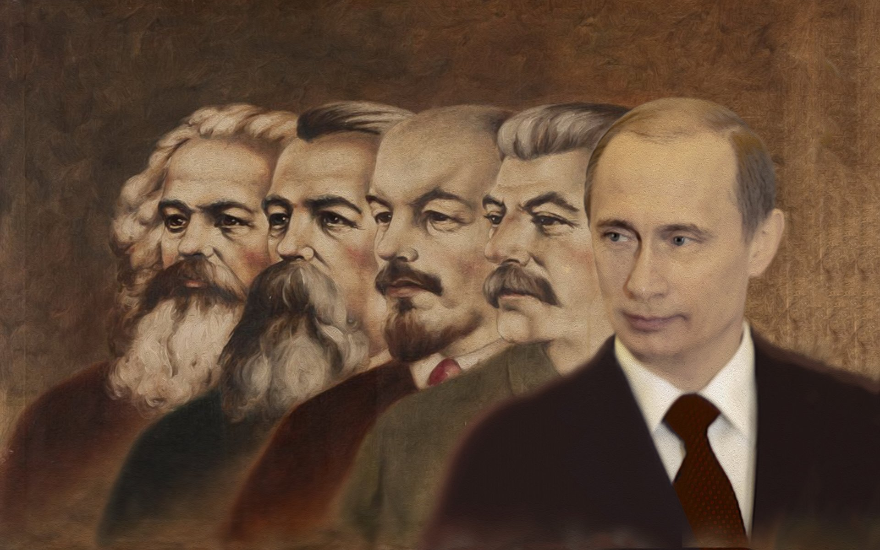

This course explores the major historical developments in Russia and the USSR since the Revolution of 1905. Topics include the fall of the tsarist autocracy, the Bolshevik victory, the social and cultural consequences of revolutionary change, Stalinism, the USSR in the Second World War, de-Stalinization, the collapse of the Soviet Union, and the rise of Vladimir Putin.

Required reading:
Be sure to buy the eighth edition of this text:
Nicholas V. Riasanovsky and Mark D. Steinberg, A History of Russia since 1855, VOLUME TWO, 8th edition (Oxford University Press, 2010) ISBN10:0195341996

Be sure to buy these specific versions of our translated works of fiction:
Isaac Babel, Red Cavalry and Other Stories (Penguin Classics, 2006) ISBN10: 0140449973
Mikhail Bulgakov, The Heart of a Dog (Grove Press, 1994) ISBN-10: 0802150594
Eugenia Ginzburg, Journey into the Whirlwind (Mariner Books, 2002) ISBN10:0156027518
Alexander Solzhenitsyn, One Day in the Life of Ivan Denisovich (Signet Classics, 2008) ISBN10:978-0451531049

Primary sources listed below and available on Sakai Resources

Requirements:
Conduct, attendance, and participation (10 points)
You are expected to attend every class, to arrive on time, to come prepared in terms of the reading and writing assignments, and to participate civilly in class discussions. You are also expected to remain in the classroom during our sessions – exceptions will be made for emergencies so long as I am notified in advance. Electronic and mobile devices are to be turned off and out of reach during class time – exceptions will be made if you are in the midst of a family emergency so long as I am notified in advance. Courtesy dictates that if you cannot attend a scheduled class, you should let me know via email or voicemail prior to that class. NB: When you send me an email, please keep in mind that these are not texts among friends, but rather communications among professionals. In other words, emails should begin with a polite and formal address (like “Dear Dr. Bernstein,”), they should be written carefully and grammatically, and they should be signed with your full name.
Written comments on primary sources (30 points total)
Ten time over the course of the semester, you are to submit prior to class via Sakai Assignments a carefully written paragraph that (1) puts something particularly striking from one of the assigned primary sources in your own words with page references inside parentheses; (2) analyzes it with regard to its meaning and historical implications; and (3) raises a relevant question for our class discussion. (This question will not count if it’s something that can easily be looked up with a Google or other search.) Each set of comments is worth up to three points. There are 12 opportunities to submit comments; you are welcome to skip two of these assignments. You also have the option to submit all 12; I will count all your accumulated points when I calculate your final grade.
Quizzes on the reading (25 points total)
There will be a short quiz at the start of four classes designated below to make sure you are prepared to discuss Babel, Bulgakov, Ginzburg, and Solzhenitsyn.
Midterm exam (10 points)
Midway through the semester, there will be an exam on the material in lectures and the assigned readings to date.
Final paper (10 points)
I will submit a current article on Russian president Vladimir Putin to the class and ask you to write a formal paper that analyzes Putin’s behavior or policy in terms of what you have learned about Soviet history.
Final exam (15 points)
At the end of the semester, there will be an exam on the entire course.

NB: Students with documented physical, mental, and learning disabilities should contact our Office of Disability Services for reasonable accommodations and services. Call the coordinator Timothy Pure (856-225-6442) or email him at tpure@rutgers.edu.

When you complete this course you will have learned:
The basic contours of 20th-century Russian political, intellectual, and social history
The factors that led to the Soviet Union’s rise and fall
How historians interpret primary sources of Russian and Soviet history
How historians read and assess secondary sources
How to understand classic works of Soviet literature in their historical context

*********
Introduction to Revolutionary Russia
Tuesday, January 17

The 1905 revolution and the Great War

Thursday, January 19
Read A History of Russia, 400-420 (optional but recommended: 421-463)

The road to revolution in 1917

Tuesday, January 24 and Thursday, January 26
Read A History of Russia, 464-486
Read and be prepared to discuss these four primary sources posted on Sakai Resources: 1-Nicholas’s Abdication; 2-Provisional Gov’t; 3-Order No. 1; 4-Lenin’s April Theses
*Comments on one of these four sources must be submitted via Sakai Assignments no later than 3:00 pm on January 26

The Bolshevik victory
Tuesday, January 31
Read A History of Russia, 487-504
Read and be prepared to discuss these five primary sources posted on Sakai Resources: 5-Lenin on seizing power; 6-Zinoviev & Kamenev protest; 7-Lenin on Constituent Assembly; 8-Trotsky on discipline; 9-Red Terror
*Comments on one of these five sources must be submitted via Sakai Assignments no later than 3:00 pm on February 2
Thursday, February 2
Read Babel’s “Red Cavalry” and be prepared to take a quiz worth five points

The New Economic Policy (NEP) and political conformity
Tuesday, February 7 and Thursday, February 9
Read A History of Russia, 505-506 and 588-606
Read and be prepared to discuss these three primary sources posted on Sakai Resources: 10-Kronstadt; 11-Lenin on Party deviations; 12-Filipenko in Delegatka
*Comments on one of these three sources must be submitted via Sakai Assignments no later than 3 pm on February 9

The revolution in culture
Tuesday, February 14
Read A History of Russia, 606-616
Read and be prepared to discuss these three primary sources posted on Sakai Resources: 13-Kollontai on Communist morality; 14-Trotsky on leisure; 15-Electrification poem
*Comments on one of these three sources must be submitted via Sakai Assignments no later than 3 pm on February 16
Thursday, February 16
Read Bulgakov’s Heart of a Dog and be prepared to take a quiz worth five points

The rise of Stalin
Tuesday, February 21 and Thursday, February 23
Read A History of Russia, 506-510
Read and be prepared to discuss these four primary sources posted on Sakai Resources: 16-Lenin’s Testament; 17-Stalin on socialism; 18-Kamenev on Stalin; 19-Stalin on opposition
*Comments on one of these four sources must be submitted via Sakai Assignments no later than 3 pm on February 23

The Stalin Revolution
Tuesday, February 28 and Thursday, March 2
Read A History of Russia, 511-522
Read and be prepared to discuss these five primary sources posted on Sakai Resources: 20-Stalin on kulaks; 21-Stalin on tempo; 22-Grossman on famine; 23-Cult of Stalin; 24-Abortion editorial
*Comments on one of these five sources must be submitted via Sakai Assignments no later than 3 pm on March 2

The Terror and Soviet society
Tuesday, March 7 and Thursday, March 9
Read A History of Russia, 522-528
Read and be prepared to discuss these four primary sources posted on Sakai Resources: 25-Stalin on deficiencies; 26-Ezhov’s Operational Order; 27-Letter to Presidium; 28-Vyshinsky summation
*Comments on one of these four sources must be submitted via Sakai Assignments no later than 3 pm on March 9

Spring break
Monday, March 13-Friday, March 17

Ginzburg and the Terror
Tuesday, March 21
Read Ginzburg’s Journey into the Whirlwind and be prepared to take a quiz worth 10 points

Midterm
Thursday, March 23

Soviet Russia at war
Tuesday, March 28 and Thursday, March 30
Read A History of Russia, 529-546
Read and be prepared to discuss these five primary sources posted on Sakai Resources: 29-Stalin’s radio address; 30-Blockade Diary; 31-Wehrmacht report; 32-Beria on deportations; 33-Lidov on Tanya
* Comments on one of these five sources must be submitted via Sakai Assignments no later than 3 pm on March 30

The postwar clampdown
Tuesday, April 4 and Thursday, April 6

Read A History of Russia, 547-558
Read and be prepared to discuss these four primary sources posted on Sakai Resources: 34-Stalin on Churchill; 35-Musicians’ letter; 36-On the West’s alliance; 37-Smirnov on vigilance
*Comments on one of these four sources must be submitted via Sakai Assignments no later than 3 pm on April 6

De-Stalinization and Khrushchev
Tuesday, April 11

Read A History of Russia, 559-565 and 575-587
Read and be prepared to discuss these four primary sources posted on Sakai Resources: 38-TsK on Beria; 39-Khrushchev’s Secret Speech; 40-Khrushchev on art; 41-Baranskaya’s Week
*Comments on one of these four sources must be submitted via Sakai Assignments no later than 3 pm on April 13
Thursday, April 13
Read and be prepared to take a quiz on One Day in the Life of Ivan Denisovich worth 5 points

Brezhnev and the “years of stagnation”
Tuesday, April 18 and Thursday, April 20
Read A History of Russia, 565-575
Read and be prepared to discuss these five primary sources posted on Sakai Resources: 42-Brezhnev in 1966; 43-Kovalev on Soviet bloc; 44-Sakharov on peace; 45-Solzhenitsyn’s letter; 46-Kuklin on jeans
*Comments on one of these five sources must be submitted via Sakai Assignments no later than 3 pm on April 20

Mikhail Gorbachev, perestroika, and the collapse of the Soviet Union

Tuesday, April 25
Read A History of Russia, 617-639
Read and be prepared to discuss these two primary sources posted on Sakai Resources: 47-Latvian Sovereignty; 48-Gorbachev’s resignation

A consideration of Vladimir Putin
Thursday, April 27
Optional, but recommended: read A History of Russia, 641-680
In advance of our final class meeting, I will post a recent article about Vladimir Putin on Sakai Resources, along with guidelines for your paper. Read and be prepared to discuss this article.
*Comments on sources 47 or 48 must be submitted via Sakai Assignments no later than 3 pm on April 27

Final course responsibilities
Tuesday, May 9
*Final paper on Putin needs to be posted on Sakai Assignments no later than 2:45 pm
*Final exam in BSB 118 from 2:45-5:45 pm

Please keep in mind that a syllabus is like a contract: it tells you what you should expect from this course, and what is expected from you. As a student in a college-level classroom, you are expected to meet the requirements specified below. If any of this poses a problem for you, please consider taking a different course.
No need to buy this book if you have A History of Russia from History 510:375.
When historians refer to “primary sources,” we don’t mean main sources but rather sources (or documents) that were created near or during the period we are investigating. Our text is a secondary source; all the documents on Sakai Resources are primary sources.

